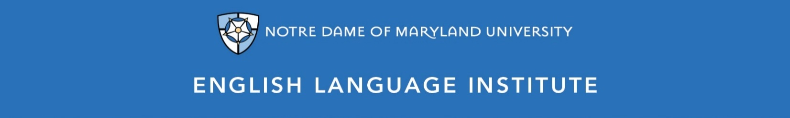

Change of Level Request Form: WRITING 003
(this section to be filled out by the student)

Name: Date:
Current Class: Teacher:
Requested Class: Teacher:
I have spoken with my current teacher (circle one): Yes / No
I want to (circle one): move up / move down
I believe I have mastered the following WRG 003 Student Learning Outcomes (check the box ☑):
WRG 003 SLOs
- Use conventional syntax to form, modify and expand basic clause patterns
- Combine clauses correctly to form compound and complex sentences in writing
- Use a variety of sentence types correctly and with intentional effect in writing
- Coordinate and subordinate information correctly and appropriately in writing and speech
- Interpret the relationships of coordinating and subordinating structures in written and spoken texts
- Form parallel constructions correctly and use them with effect in writing and speech
- Interpret and evaluate differences in meaning, tone and effect among grammatical choices
- Use grammar and syntax to communicate appropriately and comprehensibly in a range of written and spoken registers
- Recognize and correct grammatical missteps in response to feedback
- Use self-editing strategies for structural grammar errors in writing

(this section to be filled out by the teacher)
Teacher’s Comments:

Teacher recommendation: remain in level change level
Current Teacher’s Signature: ____________
Level change: approved denied
Administrator’s Signature: ________________________________

