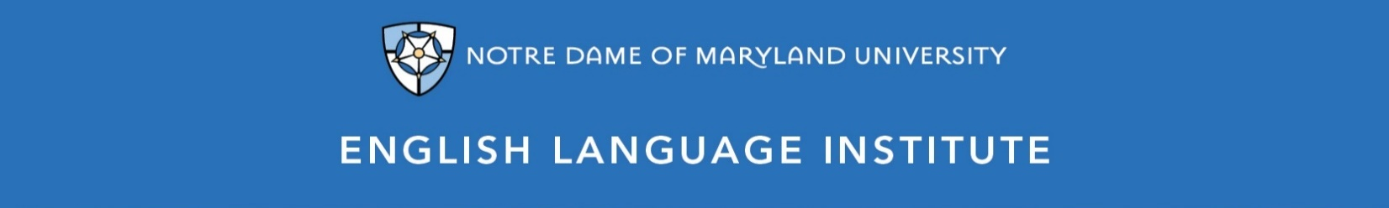

Change of Level Request Form: WRITING 002
(this section to be filled out by the student)

Name: Date:
Current Class: Teacher:
Requested Class: Teacher:
I have spoken with my current teacher (circle one): Yes / No
I want to (circle one): move up / move down
I believe I have mastered the following WRG 002 Student Learning Outcomes (check the box ☑):
WRG 002 A-SLOs
- Regularly use a variety of sentence structures in his/her writing, including compound sentences
- Begin using subordinating conjunctions, like “when” “because” “even though,” to write complex sentences, with some errors
- Take notes from authentic discussion on a variety of familiar topics
- Use the different stages of the writing process to complete a properly organized paragraph with a single purpose
- Complete a more complex and authentic form, such as a college application or a school survey
- Begin to use self-editing strategies
WRG 002 B-SLOs
- Regularly use a variety of sentence structures with correct mechanics, with some errors in complex sentences
- Write a variety of short texts for specific audiences, such as poems, brochures, infographics, and PowerPoints
- Write a short, simple report on a familiar topic that requires some research
- Connect sentences and paragraphs in a multi-paragraph text using transitions
- Produce a text whose vocabulary, purpose and tone takes audience into account
- Use the various stages of the writing process to complete a properly organized written assignment
- Complete short, TOEFL-style, timed writing assignments in class
- Use quoting and citation as a way to avoid plagiarism in his/her own written work

(this section to be filled out by the teacher)
Teacher’s Comments:

Teacher recommendation: remain in level change level
Current Teacher’s Signature: ____________
Level change: approved denied
Administrator’s Signature: ________________________________

