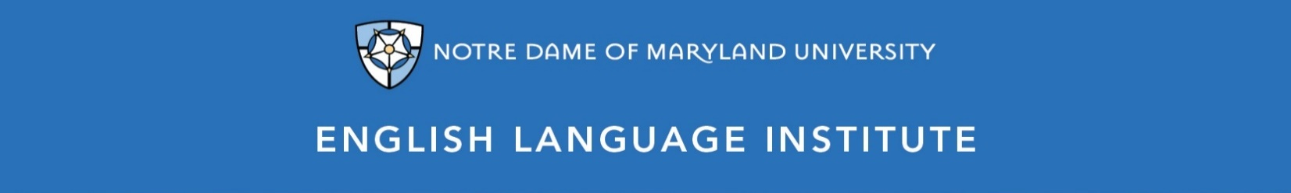

Change of Level Request Form: WRITING 001
(this section to be filled out by the student)

Name: Date:
Current Class: Teacher:
Requested Class: Teacher:
I have spoken with my current teacher (circle one): Yes / No
I want to (circle one): move up / move down
I believe I have mastered the following WRG 001 Student Learning Outcomes (check the box ☑):
WRG 001 A-SLOs
- Use a course management system, such as Joule or Canvas
- Complete a sample form or application, such as job applications, school registration forms, medical forms, etc.
- Write simple sentences and questions using correct word order
- Use sight words and practiced vocabulary correctly in a written text
- Use proper basic mechanics of capitalization and punctuation
- Write a simple paragraph of 3-5 sentences on a single topic, a personal opinion or an experience, following a model
- Write a note of personal introduction with phrases or short sentences
WRG 001 B-SLOs
- Write simple sentences and questions, with consistently correct word order and mechanics
- Begin using coordinating conjunctions, like “but” and “and,” to write compound sentences, allowing for some errors
- Use pre-writing strategies, including note-taking, outlining and graphic organizing, as part of the writing process
- Write instructions or directions with some detail, following a model
- Write short formal and informal emails related to familiar, everyday things
- Write longer, more detailed paragraphs on a variety of familiar topics

(this section to be filled out by the teacher)
Teacher’s Comments:

Teacher recommendation: remain in level change level
Current Teacher’s Signature: ____________
Level change: approved denied
Administrator’s Signature: ________________________________

