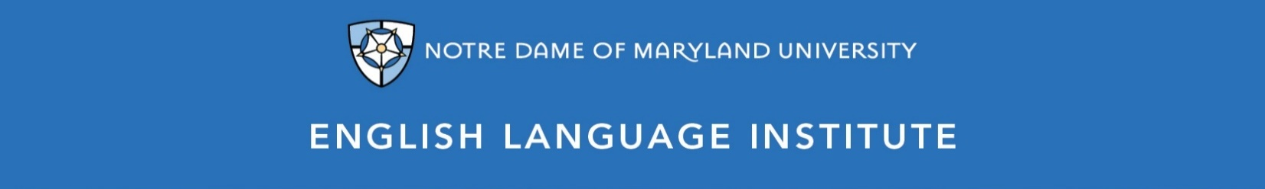

Change of Level Request Form: VOCABULARY 001
(this section to be filled out by the student)

Name: Date:
Current Class: Teacher:
Requested Class: Teacher:
I have spoken with my current teacher (circle one): Yes / No
I want to (circle one): move up / move down
I believe I have mastered the following VOC 001 Student Learning Outcomes (check the box ☑):
VOC 001 A-SLOs
- Use a foreign language to English dictionary when reading or writing a simple text
- Understand and use sight words and other very common vocabulary
- Identify and define basic compound words and understand their meaning based on their two parts (e.g. mailbox = mail + box)
- Understand and use basic vocabulary from everyday interactions, such as introductions, self-description or likes/dislikes
- Group basic words according to certain criteria, such as food, transportation or the body
- Understand and use synonyms and antonyms for basic adjectives
- Use basic language terms to talk about English (noun, verb, etc.)
- Understand and use classroom/test-taking vocabulary (e.g. fill in the blank, match, underline…, words in bold/in italics)
- Understanding the meaning of “and” and “but” and correctly use them in speaking and writing
- Understand the meaning and use of the more common modals, such as “can,” “could,” “should”)
VOC 001 B-SLOs
- Begin to use phrasal verbs and understand changes in meaning depending on the adverbial particle (“put on” vs “put off”)
- Recognize and use common everyday idioms
- Catch the meaning from an unfamiliar word based on its root, prefix or suffix
- Understand and use homonyms and homophones in speaking and writing
- Group words according to their grammatical category, such as nouns or prepositions
- Recognize and provide synonyms and antonyms for newly learned vocabulary
- Identify vocabulary according to situations/contexts (e.g. formal vs. informal, or oral vs. written communication)
- Understand the meaning of more coordinating conjunctions and use them in written and oral production, with errors
- Use the words “want,” “need,” “must/have to” appropriately in speaking and writing

(this section to be filled out by the teacher)
Teacher’s Comments:

Teacher recommendation: remain in level change level
Current Teacher’s Signature: ____________
Level change: approved denied
Administrator’s Signature: ________________________________

