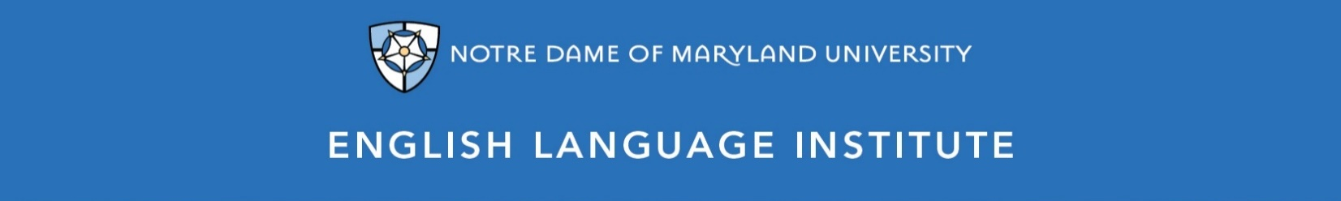

Change of Level Request Form: READING 003
(this section to be filled out by the student)

Name: Date:
Current Class: Teacher:
Requested Class: Teacher:
I have spoken with my current teacher (circle one): Yes / No
I want to (circle one): move up / move down
I believe I have mastered the following REA 003 Student Learning Outcomes (check the box ☑):
REA 003 SLOs
- Skim and scan for main ideas and supporting points within longer, complex texts for quick recall in discussion
- Read correspondence relating to his/her field of interest and readily grasp the essential meaning
- Use contextual clues and knowledge of connotation to infer meaning and tone in a dense reading with differing viewpoints
- Quickly identify the content and relevance of news items, articles and reports on a range of professional topics
- Understand lengthy, complex instructions, provided he/she can reread difficult sections
- Keep up with an animated discussion related to a text, responding to questions and comments and answering complex lines of counter argument fluently
- Keep up with a text-related debate, even on abstract, complex, unfamiliar topics

(this section to be filled out by the teacher)
Teacher’s Comments:

Teacher recommendation: remain in level change level
Current Teacher’s Signature: ____________
Level change: approved denied
Administrator’s Signature: ________________________________

