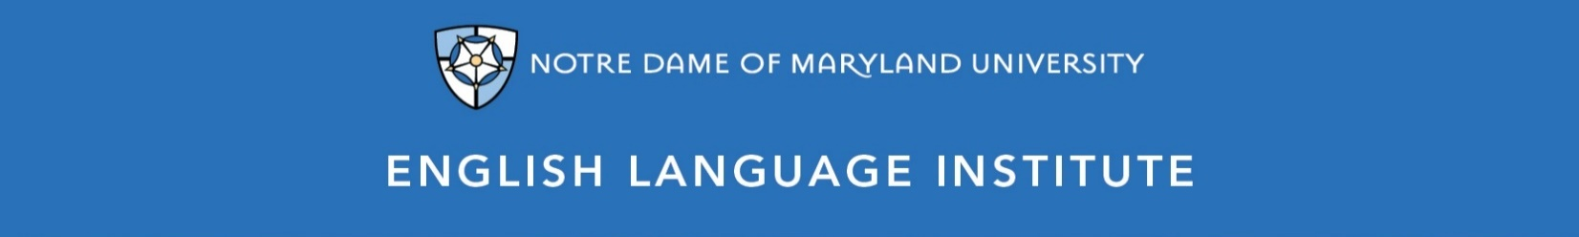

Change of Level Request Form: READING 002
(this section to be filled out by the student)

Name: Date:
Current Class: Teacher:
Requested Class: Teacher:
I have spoken with my current teacher (circle one): Yes / No
I want to (circle one): move up / move down
I believe I have mastered the following REA 002 Student Learning Outcomes (check the box ☑):
REA 002 A-SLOs
- Independently skim and scan readings for specific information and overall organization
- Understand the differences between genres, such as fiction and non-fiction, prose and poetry, articles and excerpts
- Apply a variety of strategies to figure out meaning of vocabulary, such as using background knowledge and visual clues
- Find and talk about supporting ideas and examples for main ideas within more complex texts
- Make inferences from clues found in a text
- Summarize a reading and express a personal connection to it in both writing and discussion
REA 002 B-SLOs
- Share personal and cultural information and relate it to a text, either in writing or discussion
- Find and note unfamiliar vocabulary with greater ease by skimming and scanning
- Point out respond to differences between works of fiction and non-fiction, prose and poetry, in writing or discussion
- Compare and contrast the ideas found in different texts, both in writing and discussion
- Recognize and respond to tone, such as irony, sarcasm or humor
- Summarize paragraphs and complete readings in both discussion and written responses
- Interpret complicated charts and other graphic organizers in verbal and written form

(this section to be filled out by the teacher)
Teacher’s Comments:

Teacher recommendation: remain in level change level
Current Teacher’s Signature: ____________
Level change: approved denied
Administrator’s Signature: ________________________________

