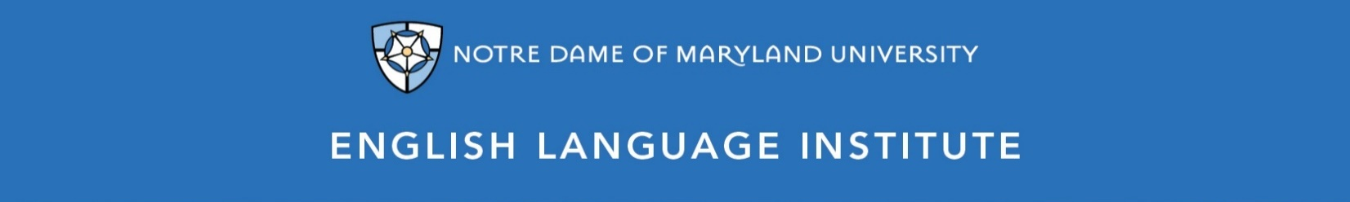

Change of Level Request Form: PRONUNCIATION 002
(this section to be filled out by the student)

Name: Date:
Current Class: Teacher:
Requested Class: Teacher:
I have spoken with my current teacher (circle one): Yes / No
I want to (circle one): move up / move down
I believe I have mastered the following PRO 002 Student Learning Outcomes (check the box ☑):
PRO 002 A-SLOs
- Understand and practice speaking chunks of linked words more fluently
- Consistently recognize and produce s-ending sounds
- Consistently use correct intonation patterns for yes/no and Wh- questions
- Consistently produce letter-sound associations for both vowels and consonants, with some errors
- Recognize and produce -ed endings more fluently
- Pronounce difficult phoneme pairs, based on learner’s needs (e.g. /l/ vs /r/ for Chinese speakers; /p/ vs /b/ for Arabic speakers
- Correctly stress newly learned multi-syllabic vocabulary
- Understand and pronounce short and long vowel sounds correctly (based on learner’s needs)
PRO 002 B-SLOs
- Recognize and correctly form and pronounce tag questions
- Consistently use correct intonation patterns for questions and statements
- Begin to understand and reproduce the schwa sound in unstressed syllables
- Pronounce phonemes needed to make yourself understood (based on learners’ needs -- /l/ vs /r/ or /b/ vs /p/)
- Consistently pronounce a broad range of word endings
- Understand and pronounce newly introduced phonemes (/R/-controlled vowels, flapped /T/, syllabic /N/, glottal /T/)
- Understand and pronounce reduced forms, including tag questions (don’t you? = don’tchoo?)
- Begin to use reduced forms, in addition to contractions, with some regularity

(this section to be filled out by the teacher)
Teacher’s Comments:

Teacher recommendation: remain in level change level
Current Teacher’s Signature: ____________
Level change: approved denied
Administrator’s Signature: ________________________________

