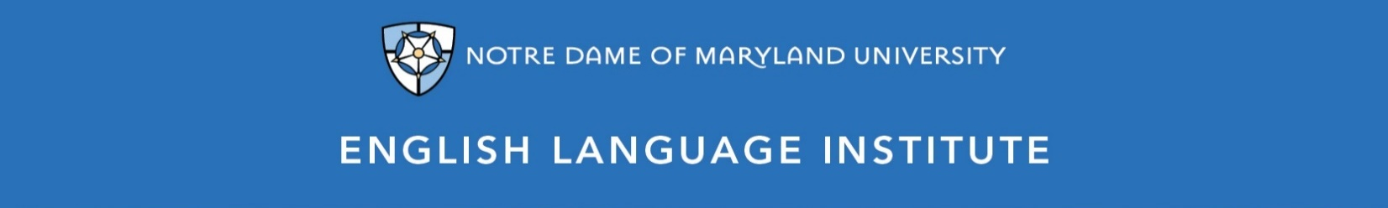

Change of Level Request Form: PRONUNCIATION 001
(this section to be filled out by the student)

Name: Date:
Current Class: Teacher:
Requested Class: Teacher:
I have spoken with my current teacher (circle one): Yes / No
I want to (circle one): move up / move down
I believe I have mastered the following PRO 001 Student Learning Outcomes (check the box ☑):
PRO 001 A-SLOs
- Understand and practice letter-sound associations (basic phonemes)
- Understand and practice one- and two-syllable word patterns
- Understand and reproduce patterns of intonation for very basic questions
- Begin to clearly pronounce some word-endings, such as s-ending sounds
- Correctly form, pronounce and use contractions (it is = it’s) for basic statements and questions
PRO 001 B-SLOs
- Understand and practice chunks or words, linking them together (“Itza” for “it is a”)
- Understand and produce syllable stress with newly learned vocabulary
- Understand and correctly produce s-ending sounds
- Begin to use proper intonation for simple yes/no and Wh- questions
- Begin to consistently make letter-sound associations for both vowels and consonants, with errors
- Begin to understand and produce -ed endings
- Use contractions for most common statements

(this section to be filled out by the teacher)
Teacher’s Comments:

Teacher recommendation: remain in level change level
Current Teacher’s Signature: ____________
Level change: approved denied
Administrator’s Signature: ________________________________

