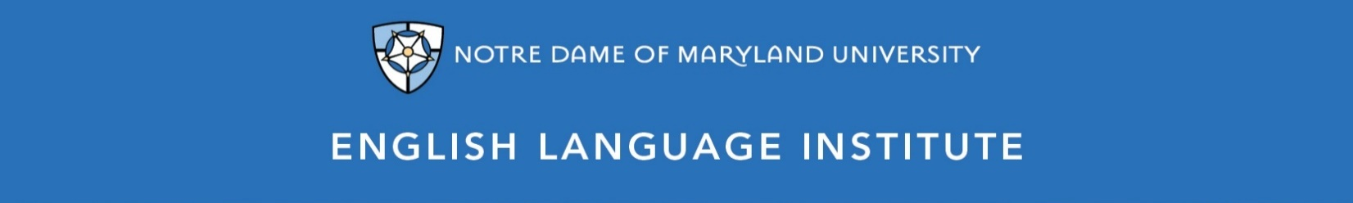

Change of Level Request Form: CONVERSATION 002
(this section to be filled out by the student)

Name: Date:
Current Class: Teacher:
Requested Class: Teacher:
I have spoken with my current teacher (circle one): Yes / No
I want to (circle one): move up / move down
I believe I have mastered the following CON 002 Student Learning Outcomes (check the box ☑):
CON 002 A-SLOs
- Express an opinion and use some evidence to defend it
- Orally compare/contrast pros & cons, points of view and other information heard in a lecture
- Use and respond to common slang, idioms and other figurative language
- Express needs and requests for information in informal or interpersonal situations
- Provide directions and instructions with more detail
- Use recently learned vocabulary words in different contexts or situations
- Take notes on, and then follow, multi-step directions related to everyday matters
- Generally follow and respond to the main points of authentic but clearly spoken native-speaker discussion
- Identify and note down the main point of straightforward, clearly spoken short talks and broadcasts on familiar topics
CON 002 B-SLOs
- Use different sentence patterns and idioms in informal conversation
- Tell anecdotal stories as part of conversations
- Select or request increasingly complex specific information
- Use a proper degree of formality in conversations and presentations
- Infer meaning from a discussion, lecture or conversation’s context
- Understand much of an authentic conversation between native speakers that are sympathetic to an English learner
- Follow and take notes on the essentials of complex lectures, talks, reports
- Identify speaker viewpoints, attitudes, mood and tone in most recorded or broadcast material
(this section to be filled out by the teacher)
Teacher’s Comments:

Teacher recommendation: remain in level change level
Current Teacher’s Signature: ____________
Level change: approved denied
Administrator’s Signature: ________________________________

