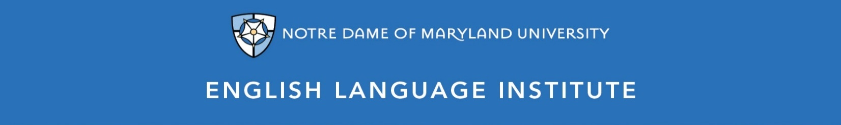

Change of Level Request Form: CONVERSATION 001
(this section to be filled out by the student)

Name: Date:
Current Class: Teacher:
Requested Class: Teacher:
I have spoken with my current teacher (circle one): Yes / No
I want to (circle one): move up / move down
I believe I have mastered the following CON 001 Student Learning Outcomes (check the box ☑):
CON 001A SLOs
- Give one- or two-step instructions on familiar topics
- Ask, recognize and respond to wh- questions about familiar topics to clarify meaning
- Connect common phrases to describe events, experiences and plans
- Express opinions and likes/dislikes on familiar topics using simple sentences.
- Express lack of understanding using common phrases
- Understand and follow simple instructions and directions that are spoken carefully and slowly
- Understand and respond to expressions showing a lack of understanding
- Understand and react to conversation openers/closers and polite expressions
CON 001B SLOs
- Retell a story by ordering multi-step procedures or events
- Orally compare and contrast facts, ideas, opinions and other information
- Do a simple interview or gather oral information
- Talk about simple opinions, (dis)agreement and (dis)satisfaction
- Consistently use proper collocations with familiar words
- Talk about heard or read information in a simple but clear way
- Order visuals according to oral instruction
- Catch and take note of the main point in clear messages and announcements
- Understand and take note of the essential information from short recorded passages and lectures about familiar matters
- Understand and react to social cues, in conversations, used by native speakers
(this section to be filled out by the teacher)
Teacher’s Comments:

Teacher recommendation: remain in level change level
Current Teacher’s Signature: ____________
Level change: approved denied
Administrator’s Signature: ________________________________

